UNITED STATES
SECURITIES AND EXCHANGE COMMISSION
Washington, D.C. 20549
Form 6-K
Report of Foreign Private Issuer
Pursuant to Rule 13a-16 or 15d-16 under the Securities Exchange Act of 1934
For the month of July 2026
Commission File Number 001-37626
Mesoblast Limited
(Exact name of Registrant as specified in its charter)
Not Applicable
(Translation of Registrant’s name into English)
Australia
(Jurisdiction of incorporation or organization)

Silviu Itescu
Chief Executive Officer and Executive Director
Level 38
55 Collins Street
Melbourne 3000
Australia
(Address of principal executive offices)

Indicate by check mark whether the registrant files or will file annual reports under cover Form 20-F or Form 40-F:
Form 20-F ☑ Form 40-F ☐

INFORMATION CONTAINED ON THIS REPORT ON FORM 6-K
On July 14, 2026, Mesoblast Limited filed with the Australian Securities Exchange a new issue announcement, notification of cessation of securities (Appendix 3H) which is attached hereto as Exhibit 99.1, and is incorporated herein by reference.
On July 14, 2026, Mesoblast Limited filed with the Australian Securities Exchange a new issue announcement, notification of issue, conversion or payment up of unquoted equity securities (Appendix 3G) which is attached hereto as Exhibit 99.2, and is incorporated herein by reference.
On July 14, 2026, Mesoblast Limited filed with the Australian Securities Exchange a new issue announcement, application for quotation of securities (Appendix 2A) which is attached hereto as Exhibit 99.3, and is incorporated herein by reference.
On July 14, 2026, Mesoblast Limited filed with the Australian Securities Exchange a new issue announcement, notification of issue, conversion or payment up of unquoted equity securities (Appendix 3G) which is attached hereto as Exhibit 99.4, and is incorporated herein by reference.
On July 14, 2026, Mesoblast Limited filed with the Australian Securities Exchange a new issue announcement, change of director’s interest notice (Appendix 3Y) which is attached hereto as Exhibit 99.5, and is incorporated herein by reference.

SIGNATURES
Pursuant to the requirements of the Securities Exchange Act of 1934, the registrant has duly caused this report to be signed on its behalf by the undersigned, thereunto duly organized.
Mesoblast Limited
/s/ Niva Sivakumar
Niva Sivakumar
Company Secretary
Dated: July 14, 2026

INDEX TO EXHIBITS
Item
99.1 |  |  |  |  |  | Appendix 3H of Mesoblast Ltd, dated July 14, 2026.
99.2 |  |  |  |  |  | Appendix 3G of Mesoblast Ltd, dated July 14, 2026.
99.3 |  |  |  |  |  | Appendix 2A of Mesoblast Ltd, dated July 14, 2026.
99.4 |  |  |  |  |  | Appendix 3G of Mesoblast Ltd, dated July 14, 2026.
99.5 |  |  |  |  |  | Appendix 3Y of Mesoblast Ltd, dated July 14, 2026.

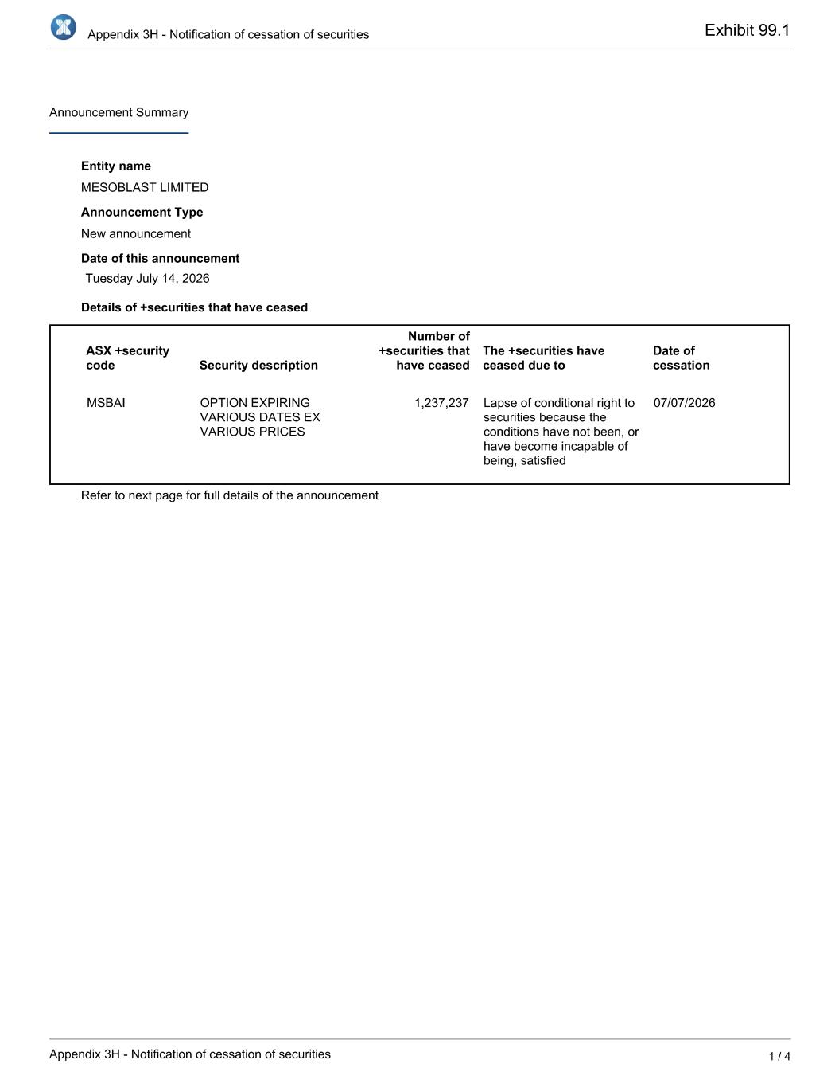

Exhibit 99.1

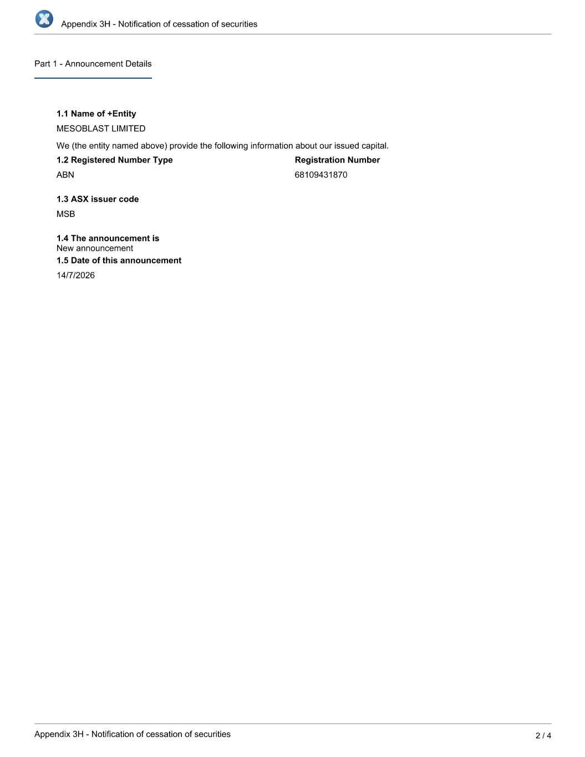

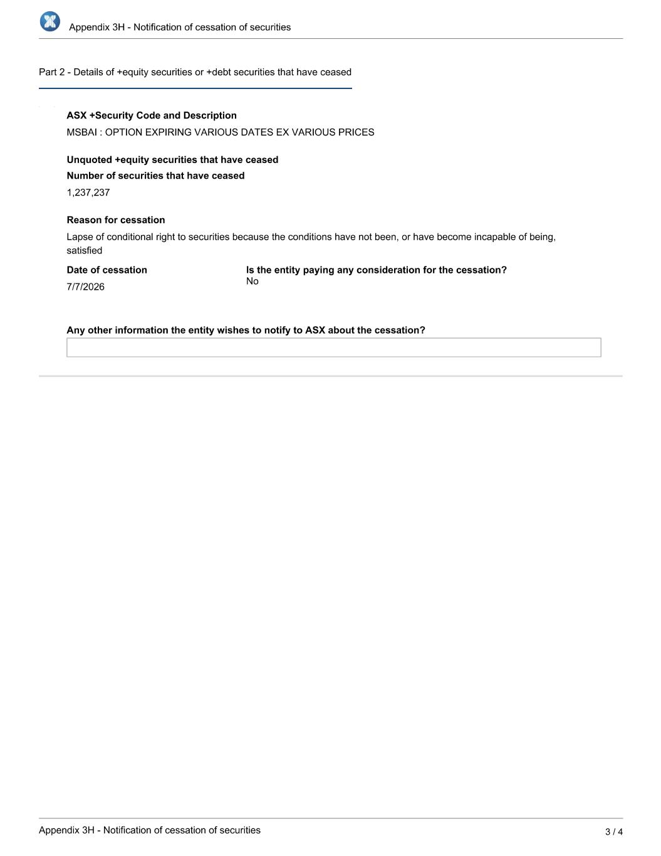

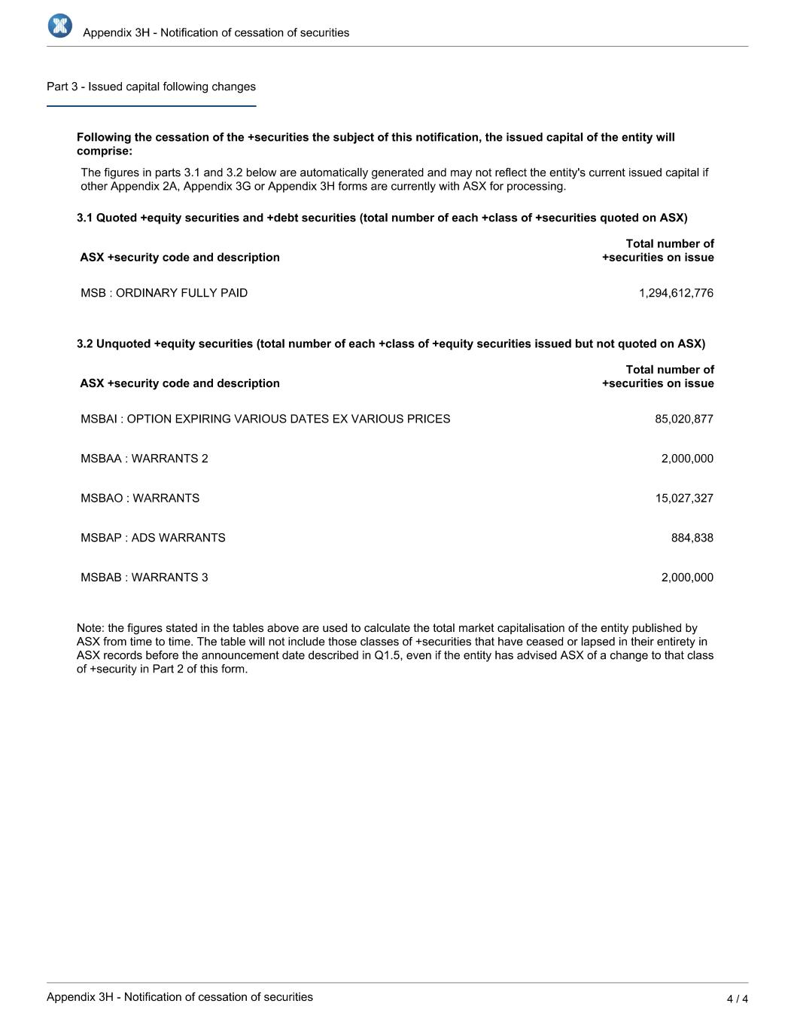

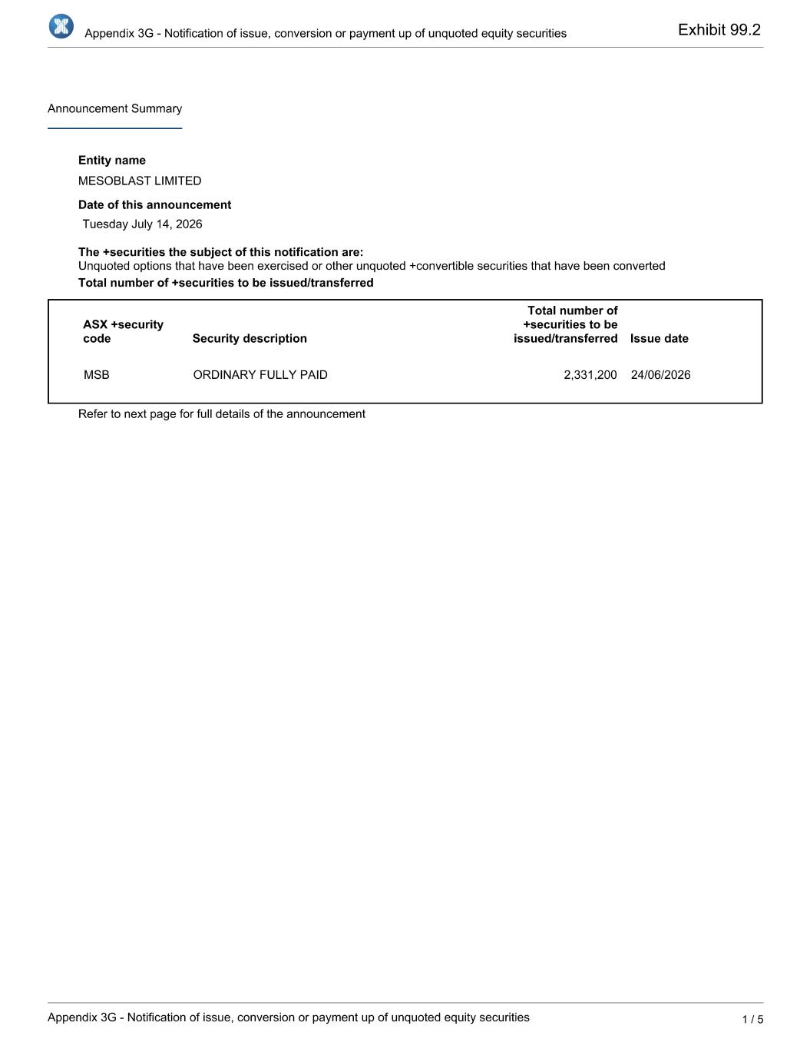
Exhibit 99.2

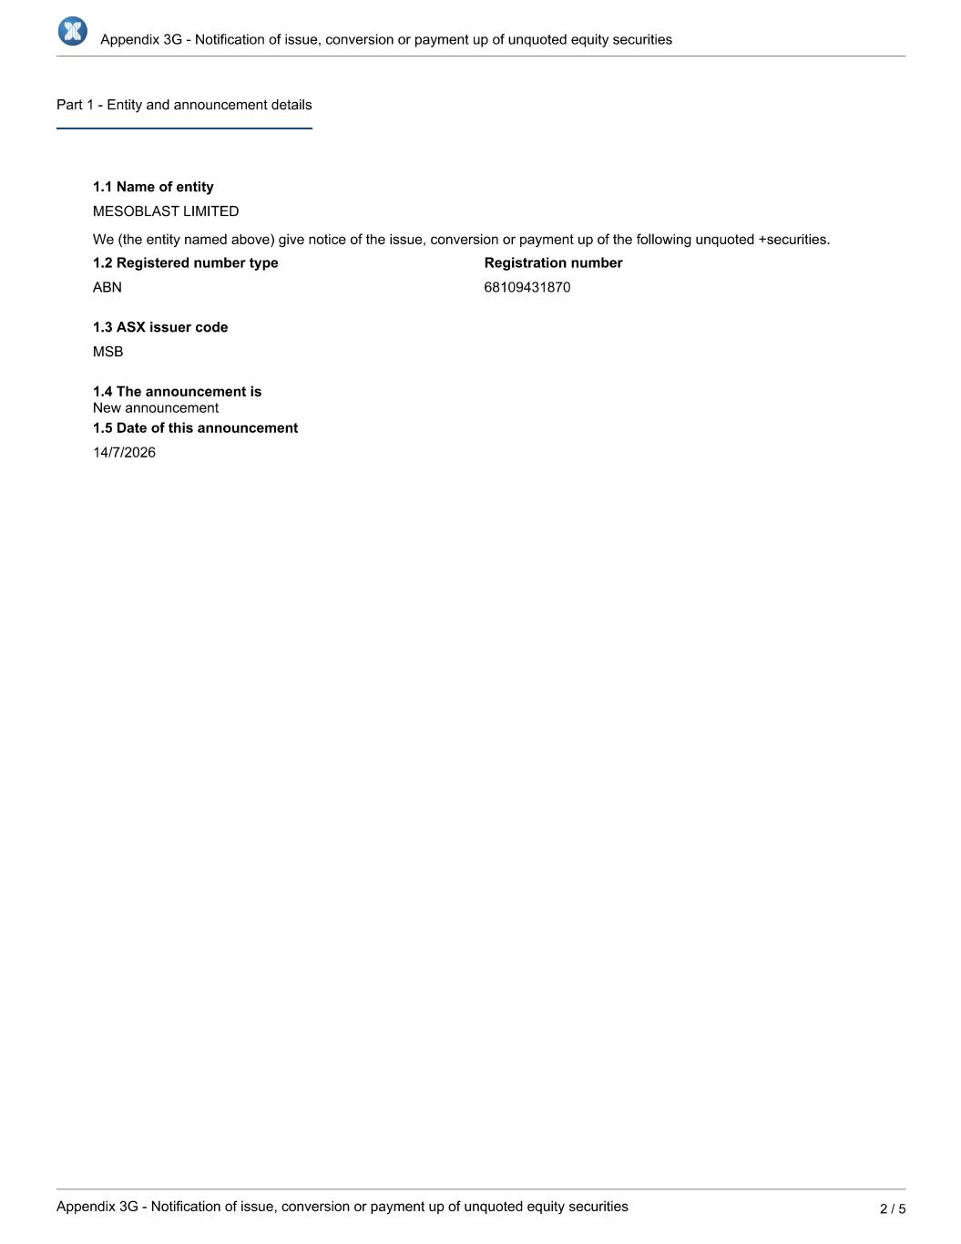

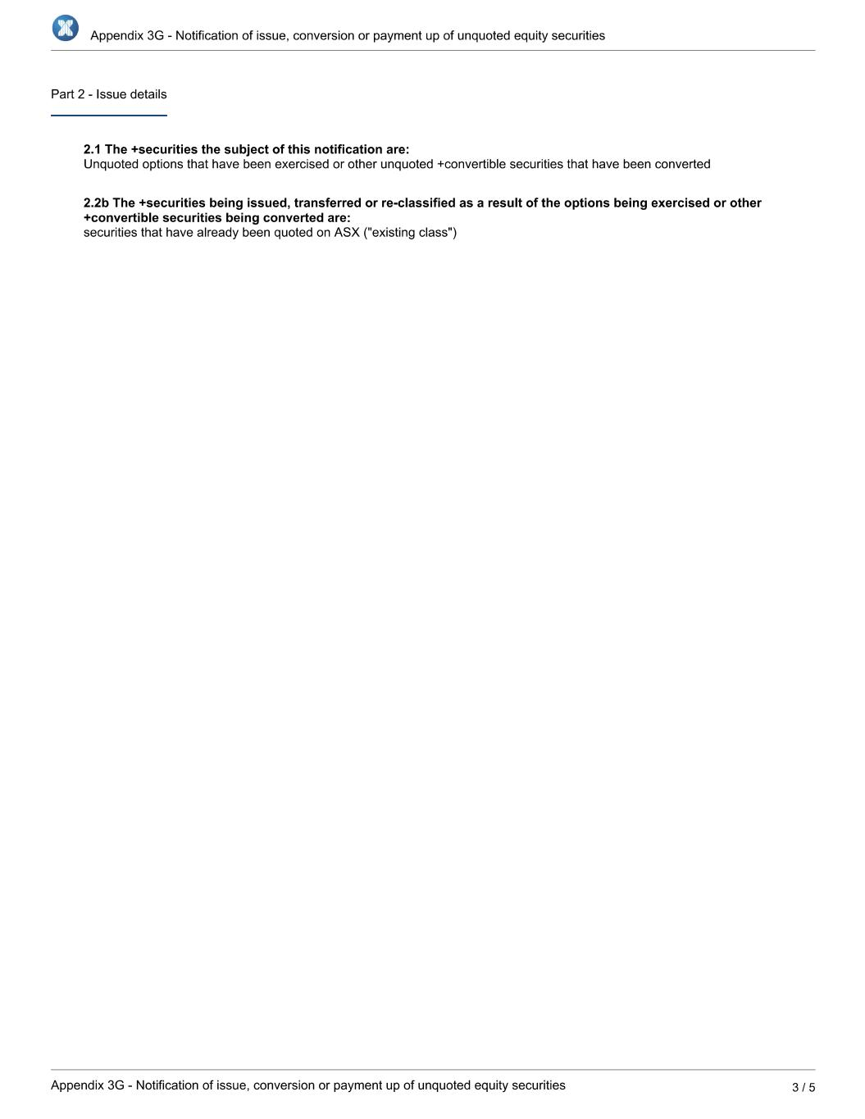

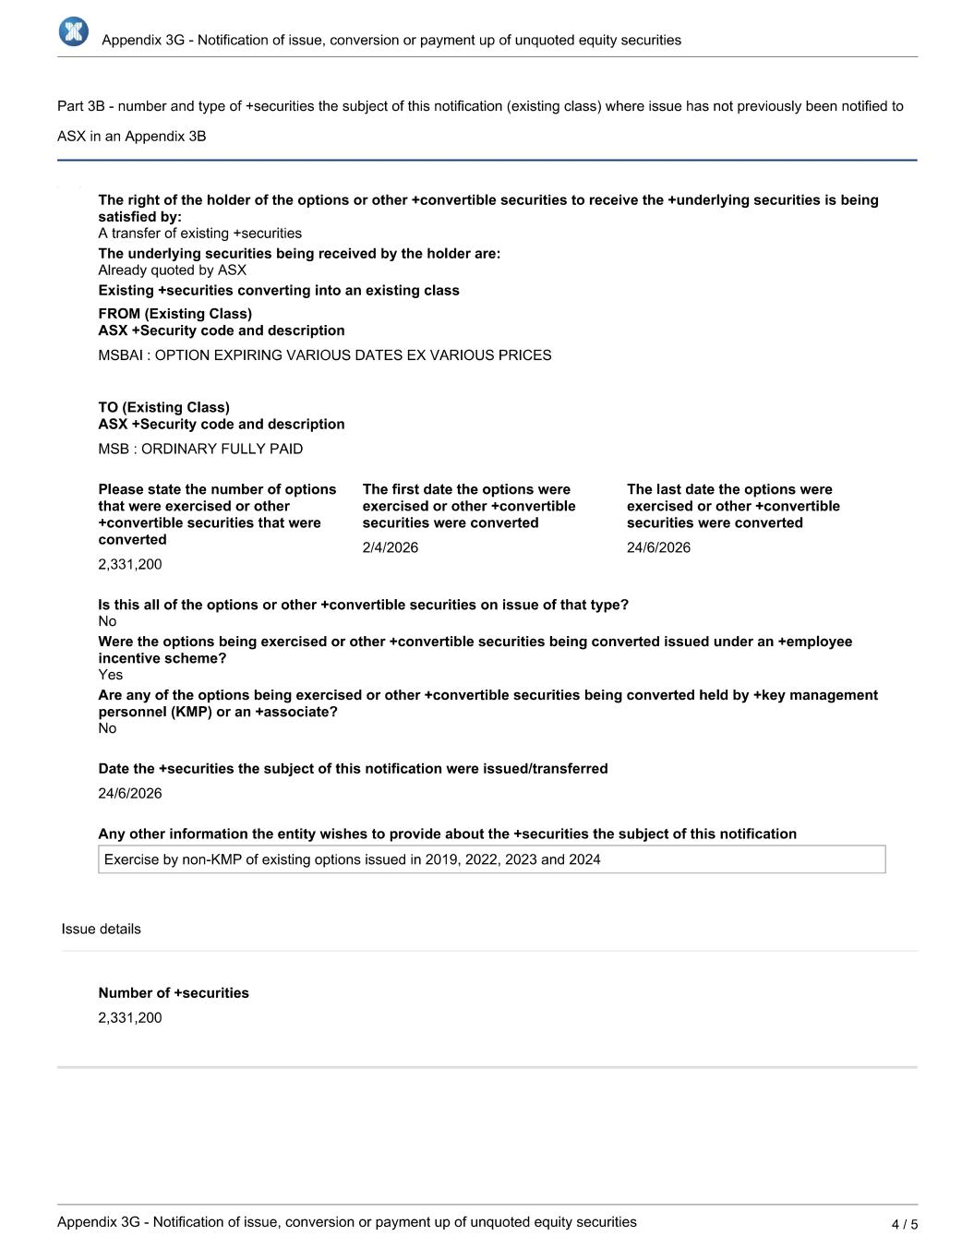

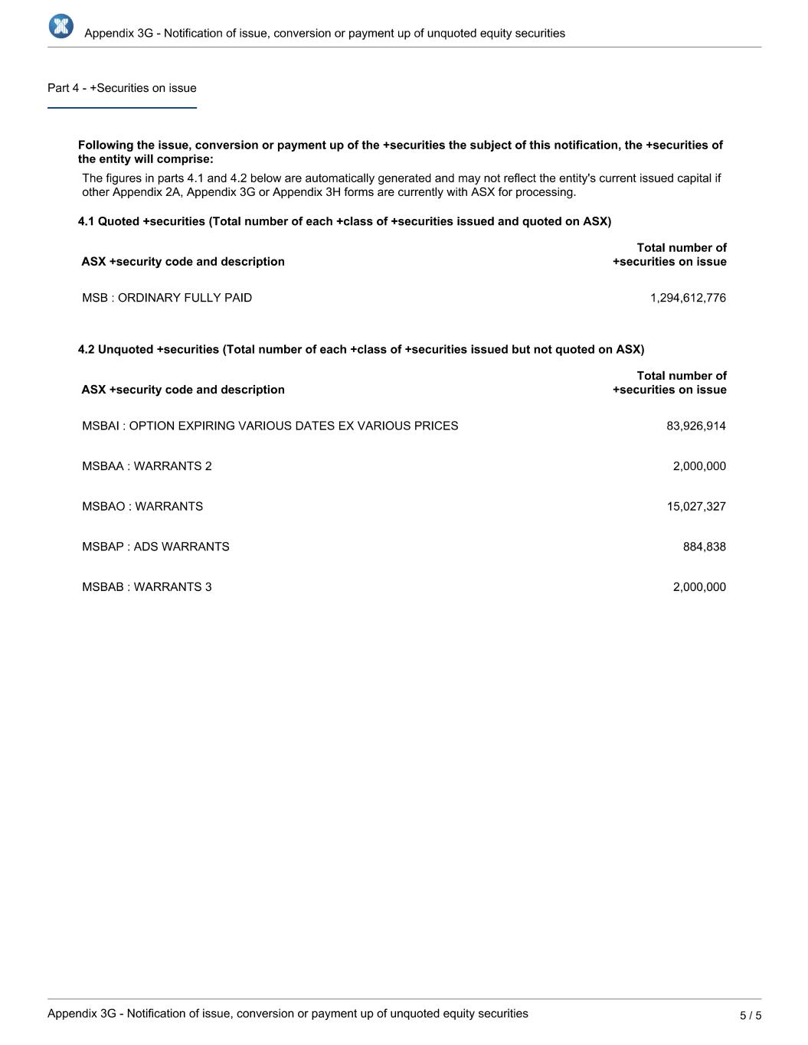

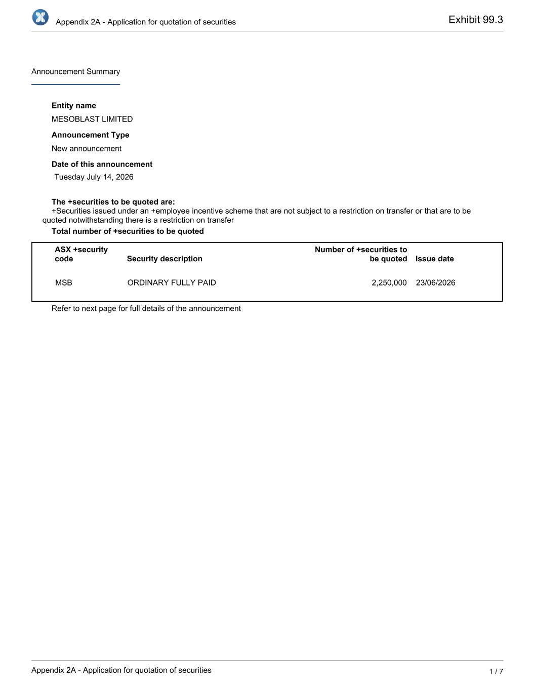
Exhibit 99.3

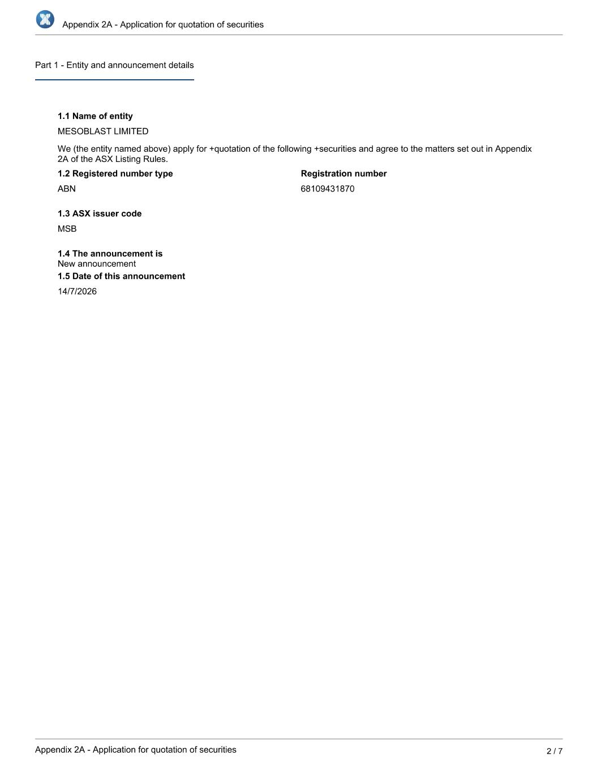

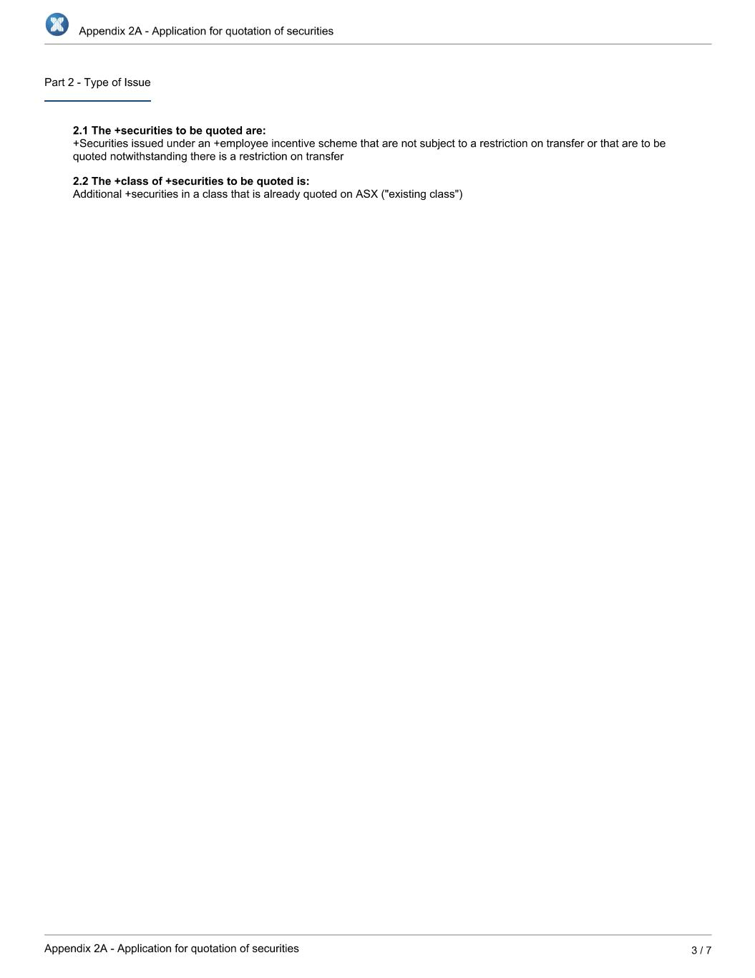

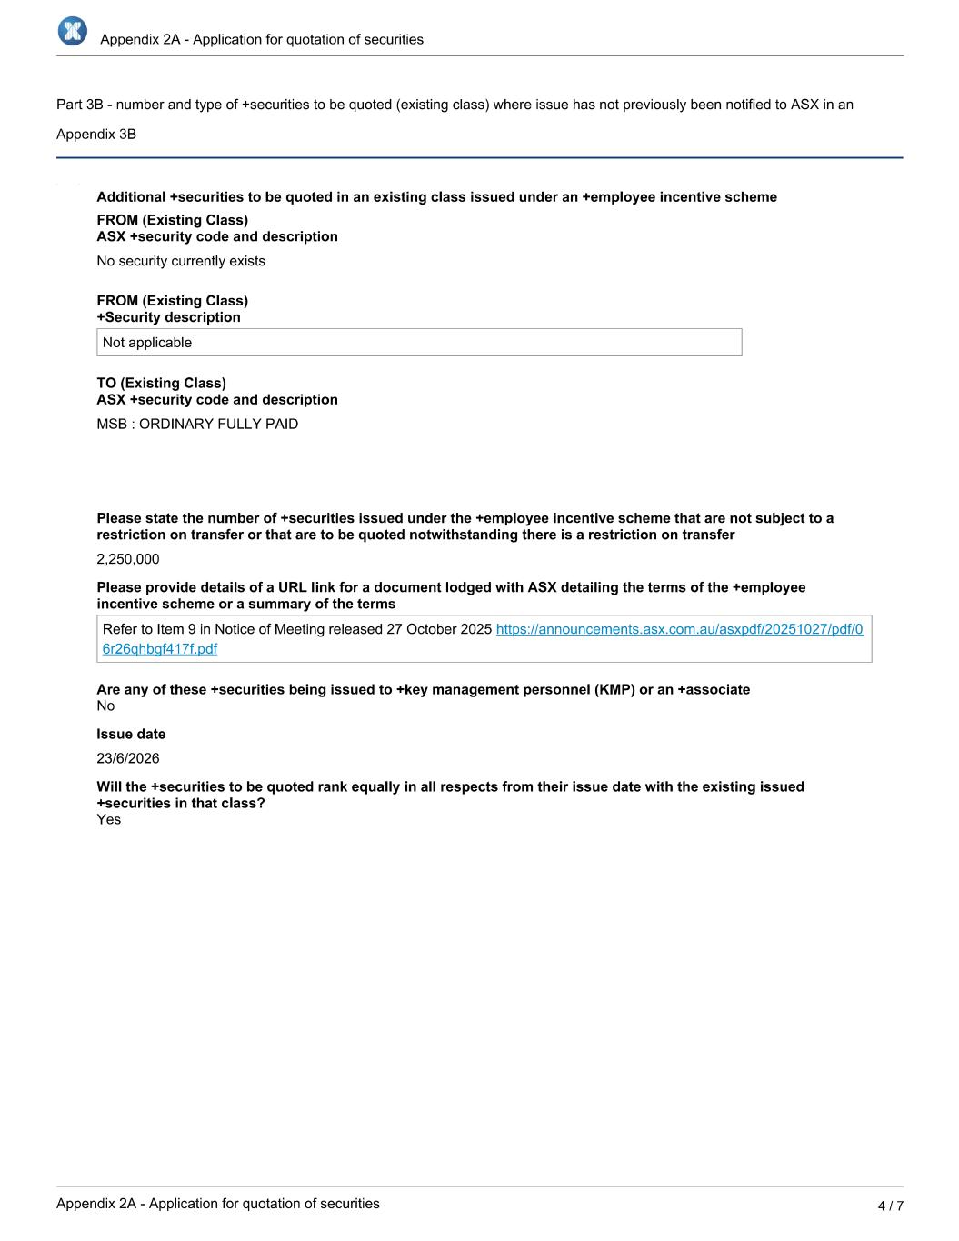

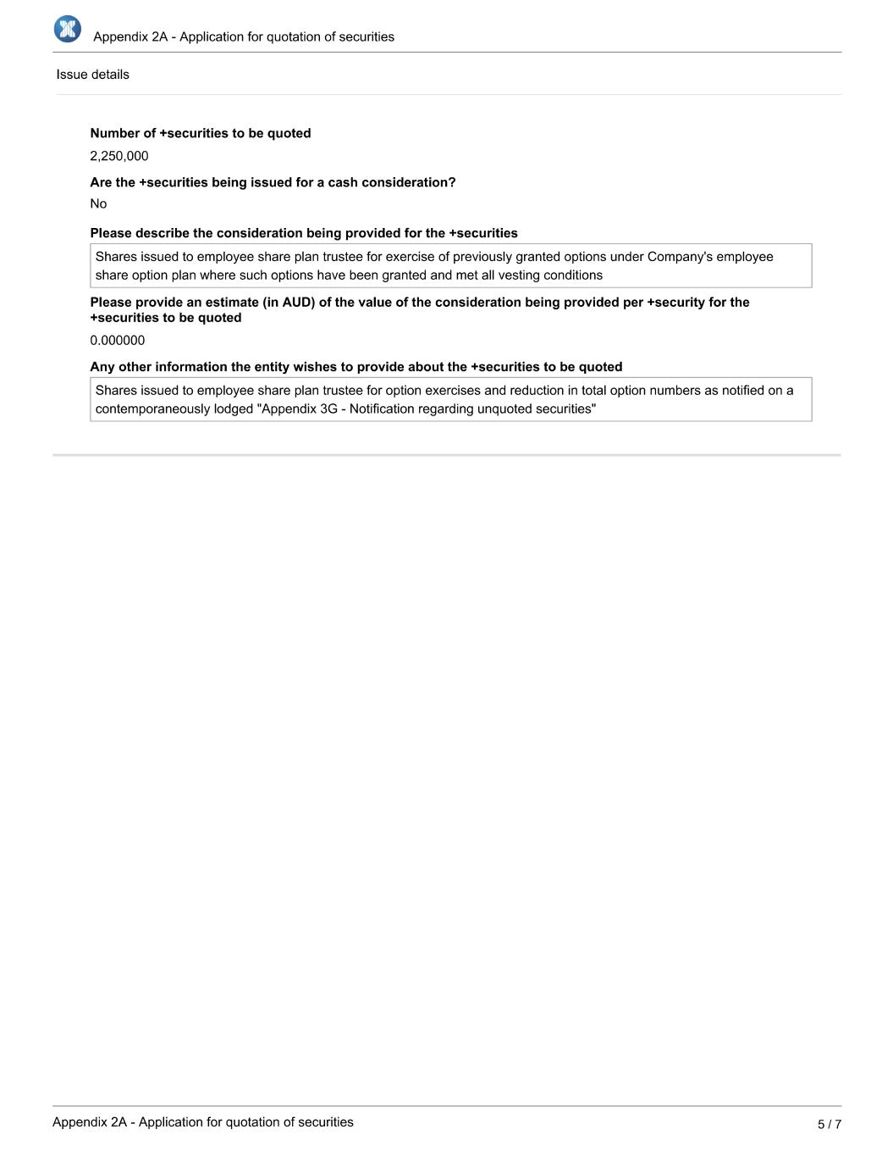

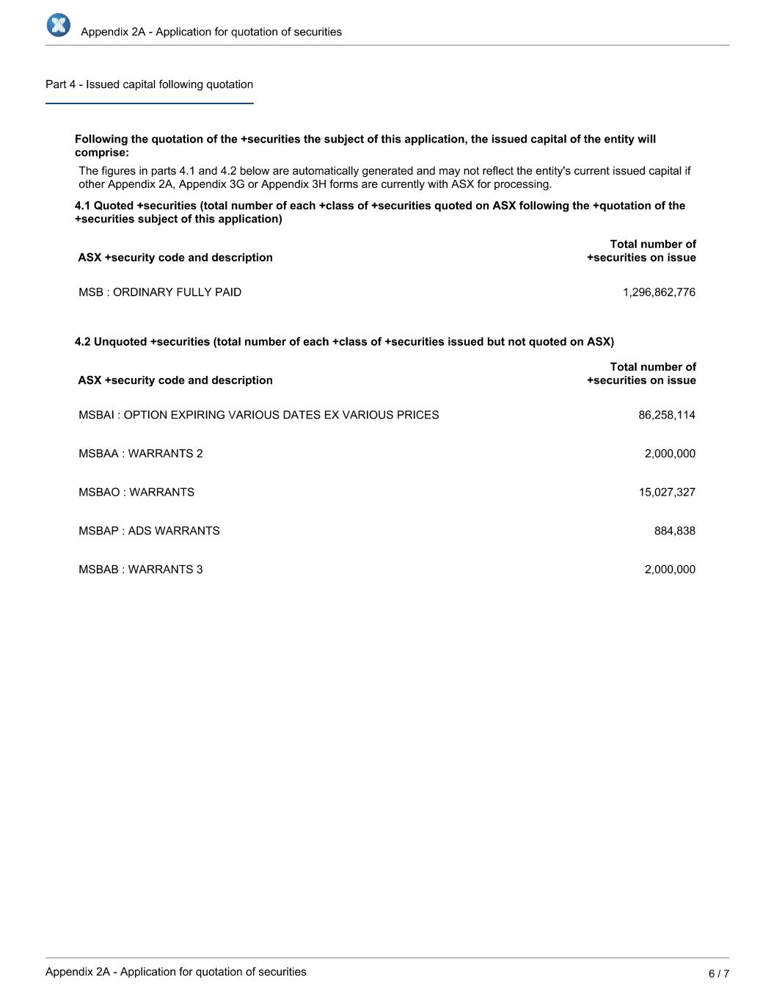

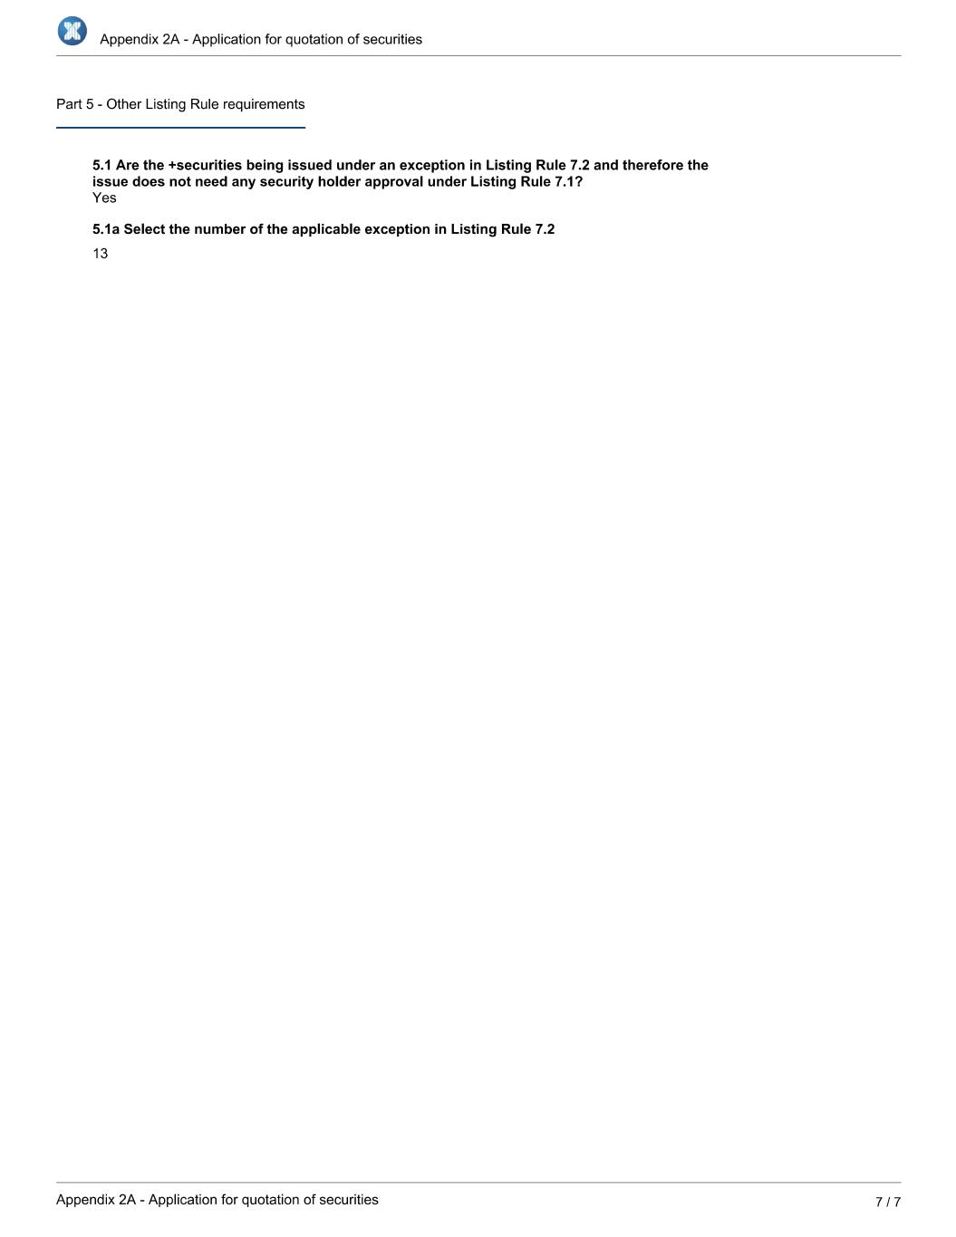

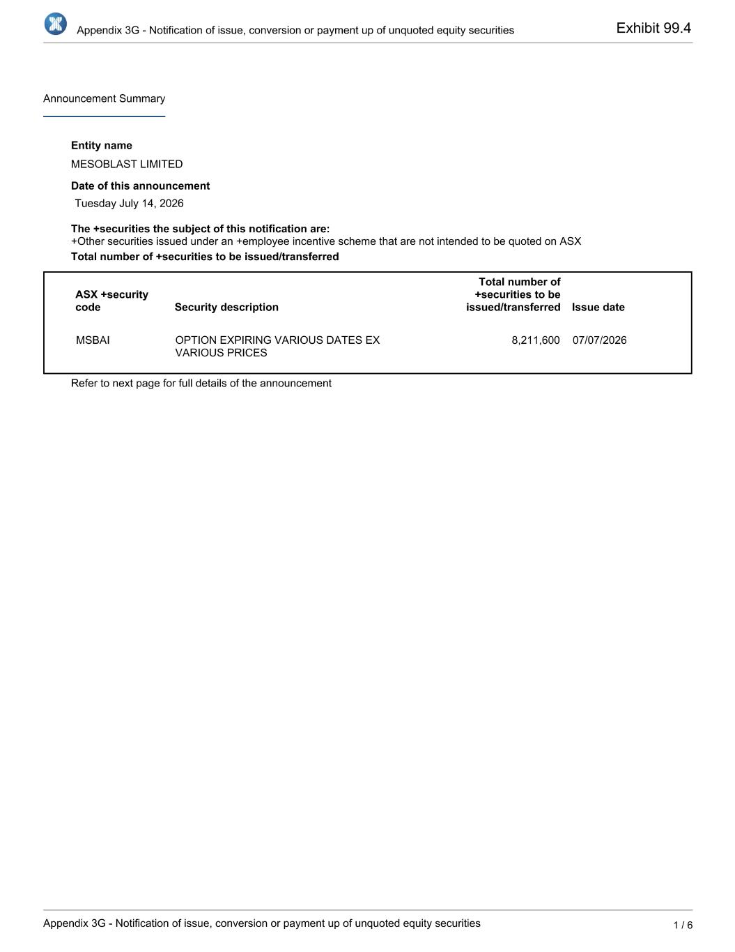
Exhibit 99.4

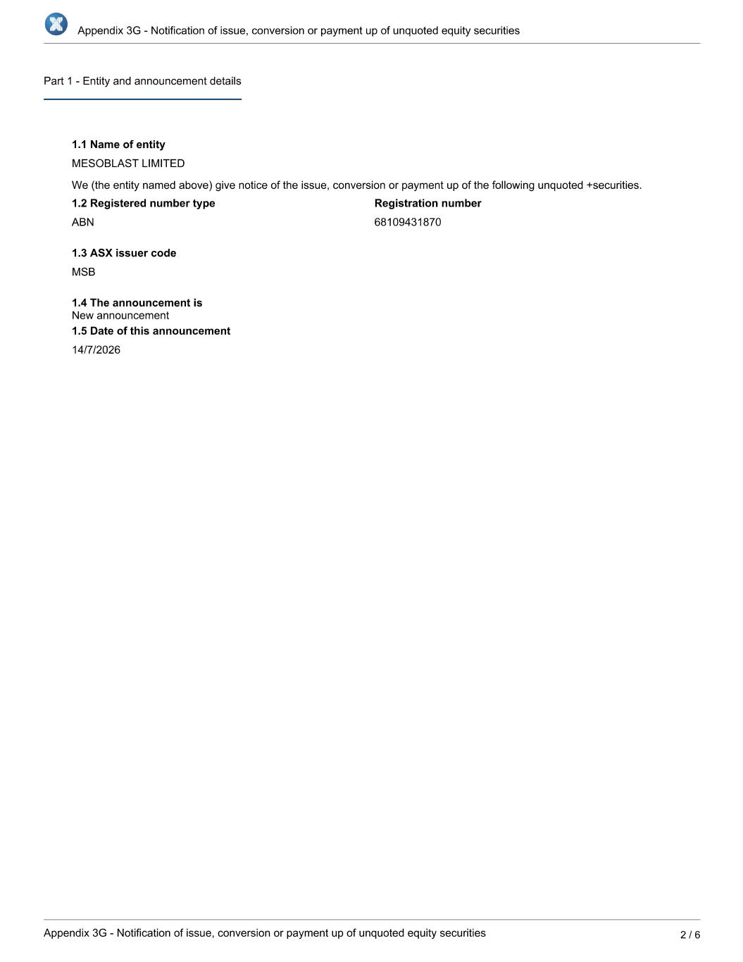

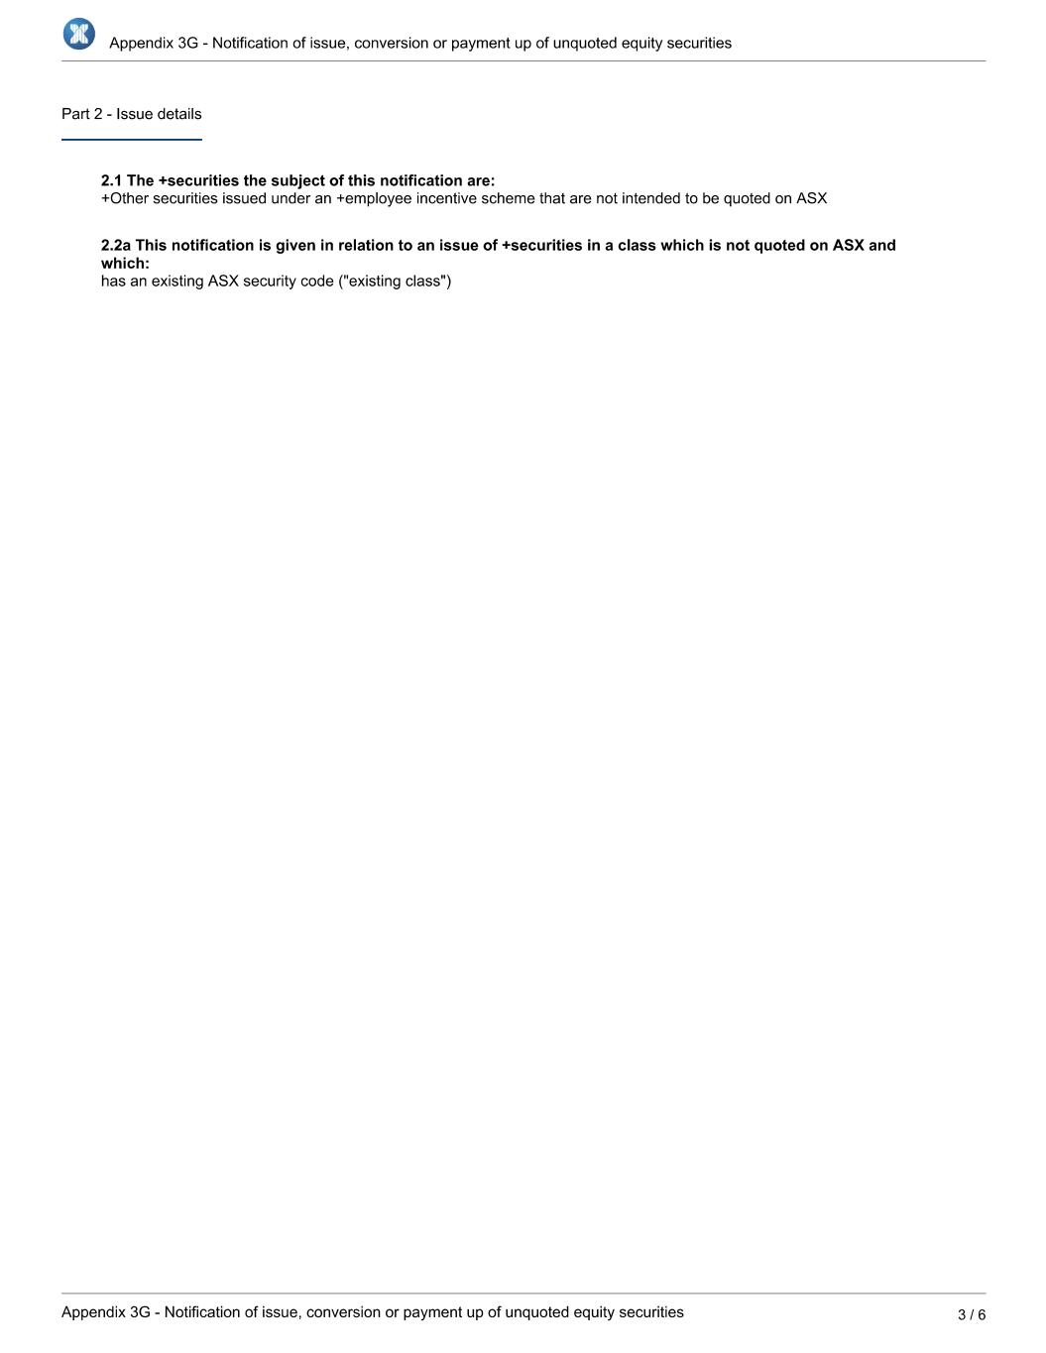

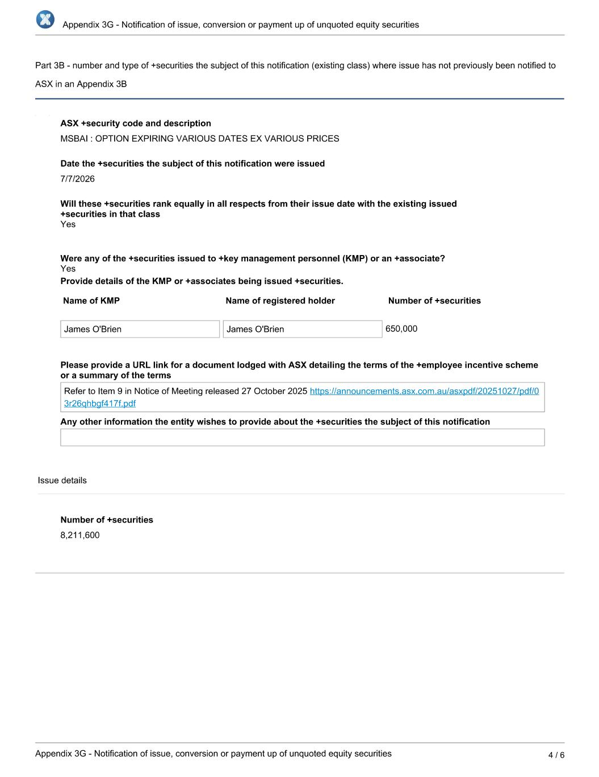

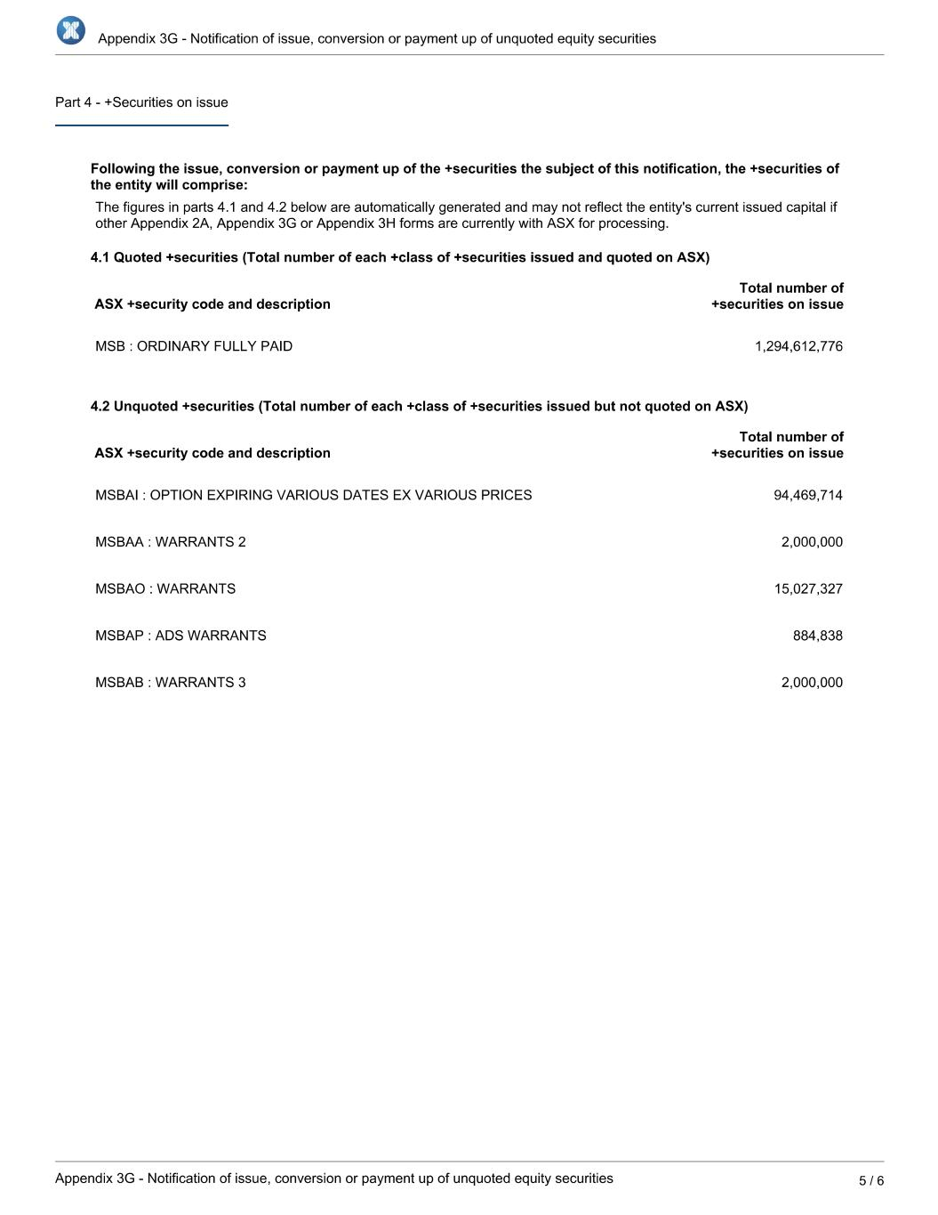

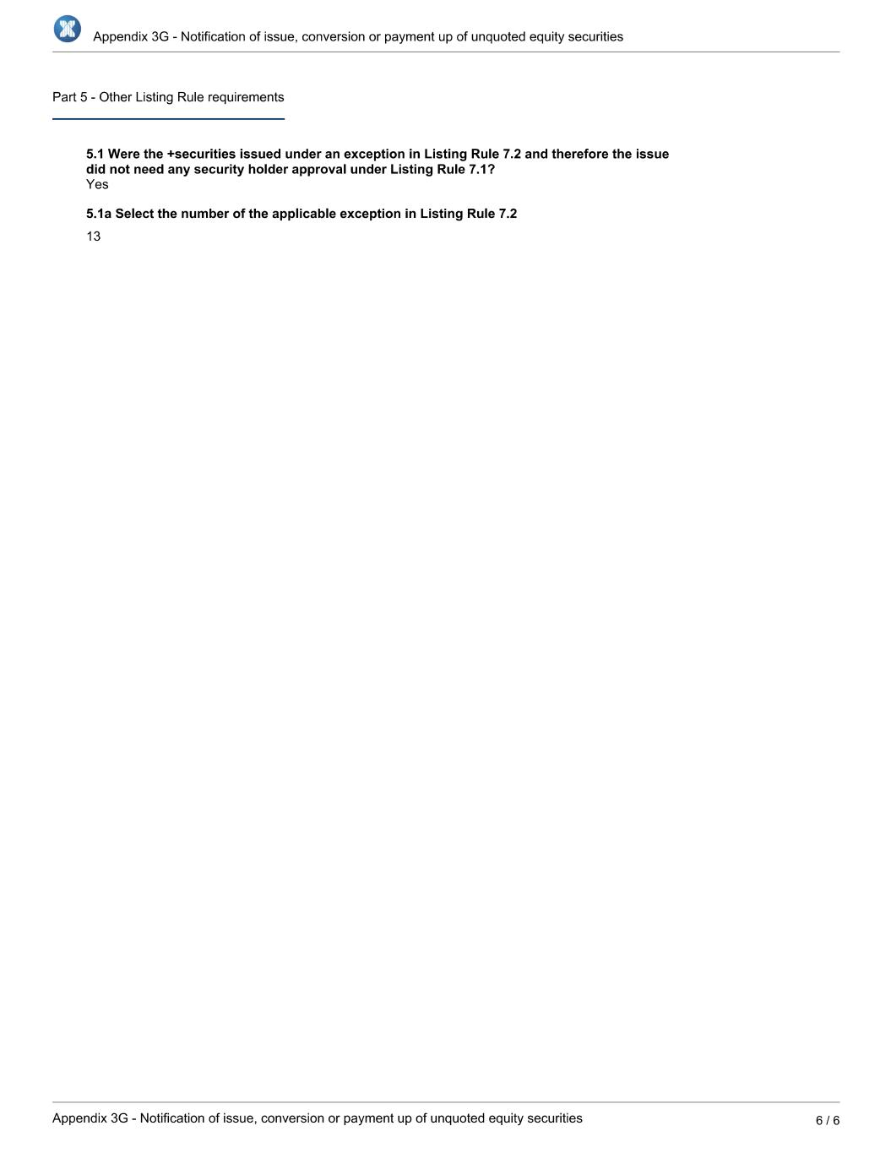

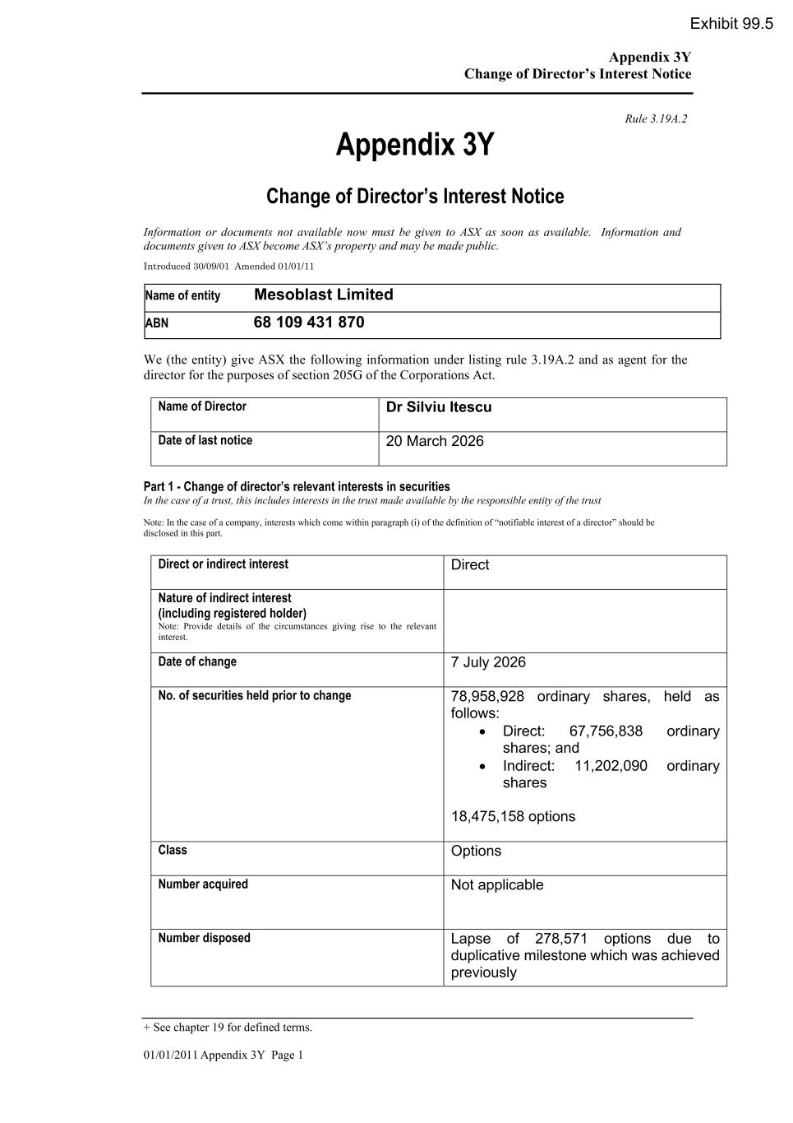
Appendix 3Y Change of Director’s Interest Notice + See chapter 19 for defined terms. 01/01/2011 Appendix 3Y Page 1 Rule 3.19A.2 Appendix 3Y Change of Director’s Interest Notice Information or documents not available now must be given to ASX as soon as available. Information and documents given to ASX become ASX’s property and may be made public. Introduced 30/09/01 Amended 01/01/11 Name of entity Mesoblast Limited ABN 68 109 431 870 We (the entity) give ASX the following information under listing rule 3.19A.2 and as agent for the director for the purposes of section 205G of the Corporations Act. Name of Director Dr Silviu Itescu Date of last notice 20 March 2026 Part 1 - Change of director’s relevant interests in securities In the case of a trust, this includes interests in the trust made available by the responsible entity of the trust Note: In the case of a company, interests which come within paragraph (i) of the definition of “notifiable interest of a director” should be disclosed in this part. Direct or indirect interest Direct Nature of indirect interest (including registered holder) Note: Provide details of the circumstances giving rise to the relevant interest. Date of change 7 July 2026 No. of securities held prior to change 78,958,928 ordinary shares, held as follows: • Direct: 67,756,838 ordinary shares; and • Indirect: 11,202,090 ordinary shares 18,475,158 options Class Options Number acquired Not applicable Number disposed Lapse of 278,571 options due to duplicative milestone which was achieved previously Exhibit 99.5

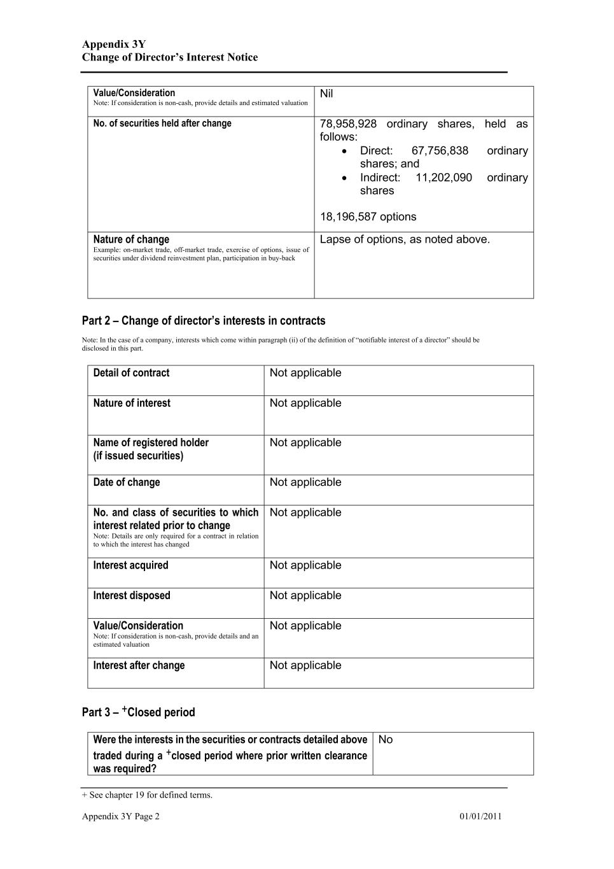
Appendix 3Y Change of Director’s Interest Notice + See chapter 19 for defined terms. Appendix 3Y Page 2 01/01/2011 Value/Consideration Note: If consideration is non-cash, provide details and estimated valuation Nil No. of securities held after change 78,958,928 ordinary shares, held as follows: • Direct: 67,756,838 ordinary shares; and • Indirect: 11,202,090 ordinary shares 18,196,587 options Nature of change Example: on-market trade, off-market trade, exercise of options, issue of securities under dividend reinvestment plan, participation in buy-back Lapse of options, as noted above. Part 2 – Change of director’s interests in contracts Note: In the case of a company, interests which come within paragraph (ii) of the definition of “notifiable interest of a director” should be disclosed in this part. Detail of contract Not applicable Nature of interest Not applicable Name of registered holder (if issued securities) Not applicable Date of change Not applicable No. and class of securities to which interest related prior to change Note: Details are only required for a contract in relation to which the interest has changed Not applicable Interest acquired Not applicable Interest disposed Not applicable Value/Consideration Note: If consideration is non-cash, provide details and an estimated valuation Not applicable Interest after change Not applicable Part 3 – +Closed period Were the interests in the securities or contracts detailed above traded during a +closed period where prior written clearance was required? No

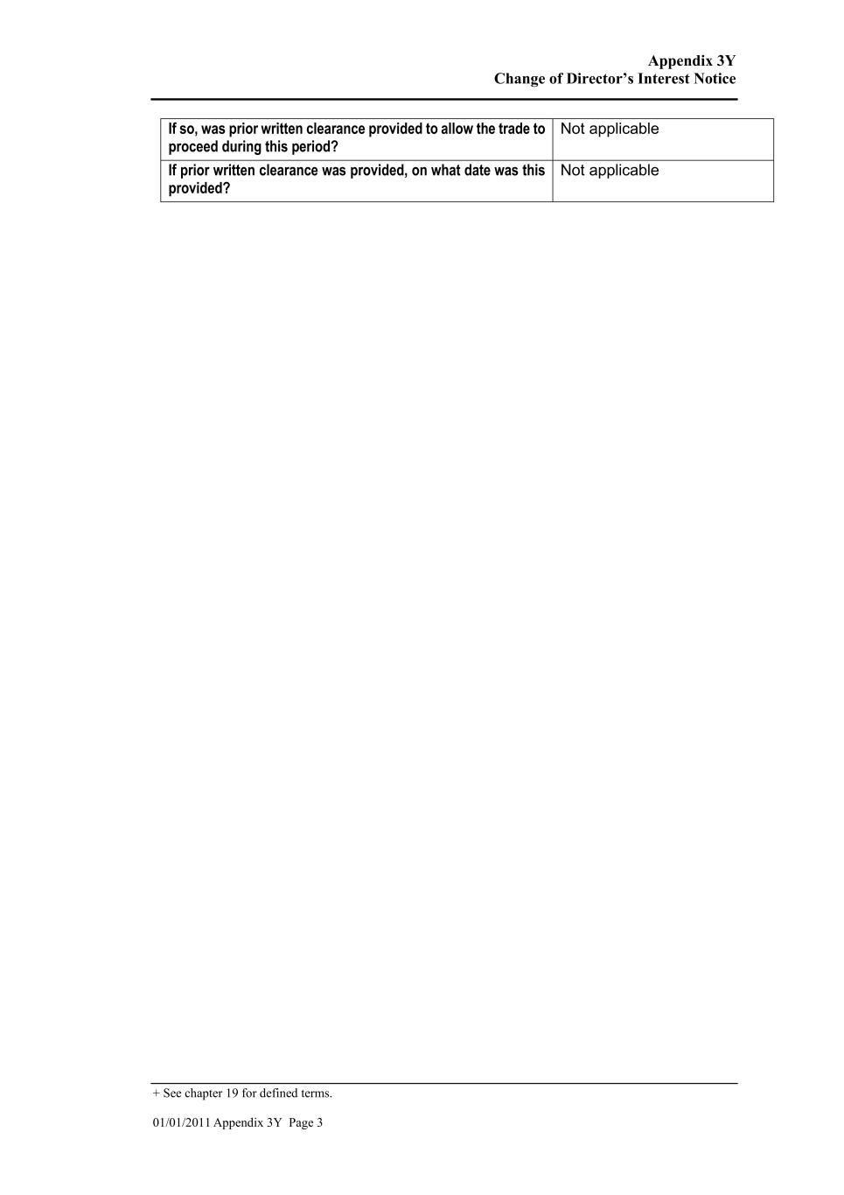
Appendix 3Y Change of Director’s Interest Notice + See chapter 19 for defined terms. 01/01/2011 Appendix 3Y Page 3 If so, was prior written clearance provided to allow the trade to proceed during this period? Not applicable If prior written clearance was provided, on what date was this provided? Not applicable

